Set Tayo Ng Date
Use Case Diagram

Submitted to:

Prof. Ma. Rowena C. Solamo
Faculty Member
Department of Computer Science
College of Engineering
University of the Philippines, Diliman

Submitted by:
Bandong, Arvin
Bariring, Edward James
Rosales, Kyle

In partial fulfillment of Academic Requirements
for the course
CS 191 Software Engineering I
of the
1st Semester, AY <2016-2017>

Unique Reference:
The documents are stored in the https://github.com/DarkPotatoKing/cs-191-192-repo
Folder link: https://github.com/DarkPotatoKing/cs-191-192-repo/tree/master/02-Requirements%20Engineering

Document Purpose:
This document serves to give the audience the events that they will run into when using the software.

Target Audience:
Target audience is the user that’s going to use said software.

Revision Control

History Revision:
Revision Date | Person Responsible | Version  Number | Modification
09/24/16 | Kyle Rosales | 1.0 | Initial Document
09/26/16  9/29/16 | Kyle Rosales  Arvin Bandong | 1.1  1.2  1.3 | Add user description and list of use cases  Added UCM, description of Edit Schedule and Delete Schedule  Edited the "Edit Schedule" and "Delete Schedule" description
9/29/16 | Edward James Bariring | 1.4 | Edited “View Schedules” and “Add Schedule” description

System Name: Set Tayo Ng Date

Description: This software allows people in a group to input their schedules into the
software's database. It is a tool to help people set meetings when everyone
in the group is free by displaying everyone's schedules. It also has advance
search options which lets you answer questions like "When is Alice, Bob,
and Charlie free between 10 am and 2 pm?

Use-Case Diagram:

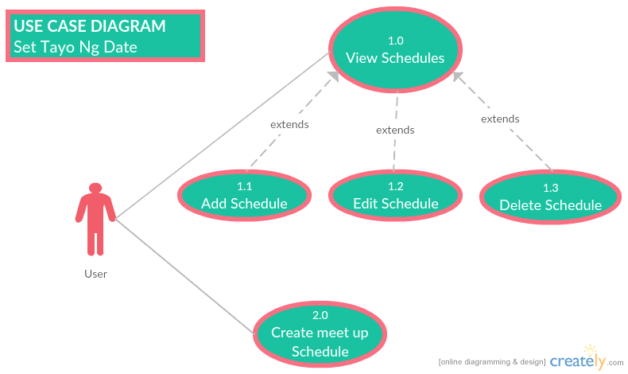

List of Actors:
Actors | Description
User | Any person such as a group leader or a project manager who is using the software to set aschedule between the group. The user is the one who keeps track of everyone's schedules. The user is also the one who sets meetings within the group.

List of Use-cases:
Use-Case | Description
Use-Case 1.0 View schedules | The user will see the schedules inputted from use case 1.2. In case of having no schedule inputted, user will be presented an option to create a new meetup schedule that will be displayed later.
Use-Case 1.1 Add schedule | The user will get the schedules of the people he/she will meet and puts it in the software. After inputting a schedule of a person, user will be presented an option to add another schedule for another person. After putting all schedules, user will be presented the option to save said schedules.
Use-Case 1.2 Edit schedule | The user can edit any available schedule. He can either search  the name of the person that he wishes to edit, or manually scan  it from the list. After finding the desired schedule table, he can  now click “Edit” button and apply the changes he wants to make.  After the changes that he made, he can choose to either save  or cancel those changes.
Use-Case 1.3 Delete schedule | The user can delete any existing schedule table. He can either search the name of the person that he wishes to delete, or manually scan it from the list. After finding the desired schedule table, he can now click the "Delete" button and a confirmation message will appear. Deletion will proceed if "Yes" is selected and it will be canceled if "No" is selected.
Use-Case 2.0 Create meetup schedule | The user can create a meetup schedule. The user inputs the time range for the meetup and the required members for that meetup. The software displays all schedules within the time range where all the required members are free at that time. The user selects one schedule as the meeting schedule and it goes to the “List of Upcoming Meetings”.

